
BioAmp v1.5 Instructions
March 2021

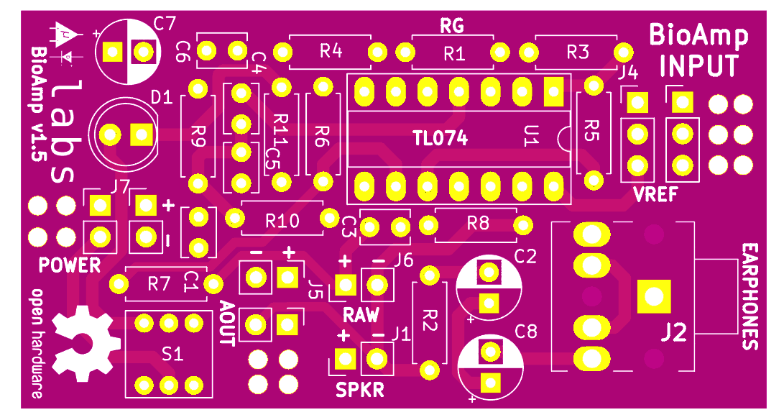
Materials Needed:
1. DIY BioAmp v1.5 Bag of Parts
2. Soldering Iron
3. Solder
4. Magnifying Glass to read labels on Capacitors
5. Silly Putty to hold components in place on board while you solder on the back of the board
6. Wire Strippers and Wire Clippers to trim leads

BioAmp v1.5 BOM:

Ref | Qnty | Value
C1, | 1 | 4.7-100nf
C2, C7, C8, | 3 | 47uf
C3, | 1 | 4.7nf
C4, C5, C6, | 3 | 100nf
D1, | 1 | RED LED
J1, J5, J6, J7, | 4 | Conn_01x02_Male
J2, | 1 | PJ-3062-CO
J4, | 1 | Conn_01x03_Male
R1, R2, R5, R6, R7, R8, | 6 | 10k
R3, R4, | 2 | 220k
R9, R10, | 2 | 100k
R11, | 1 | 1k
SW1, | 1 | DPDT_7x7x12mm
U1, | 1 | TL074
Alligator clips | 3 | Mini
3.5mm male | 1 | Jack with casing
BioAmp v1.5 PCB | 1 | PCB Board
Wires + Heat shrink | - | -

BioAmp v1.5 Circuit Construction:

Resistors
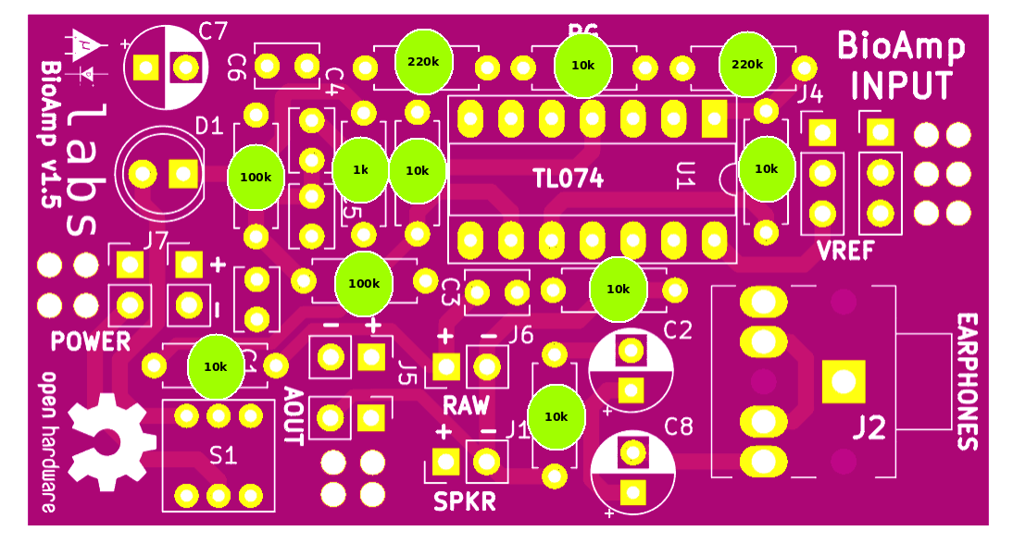

Capacitors
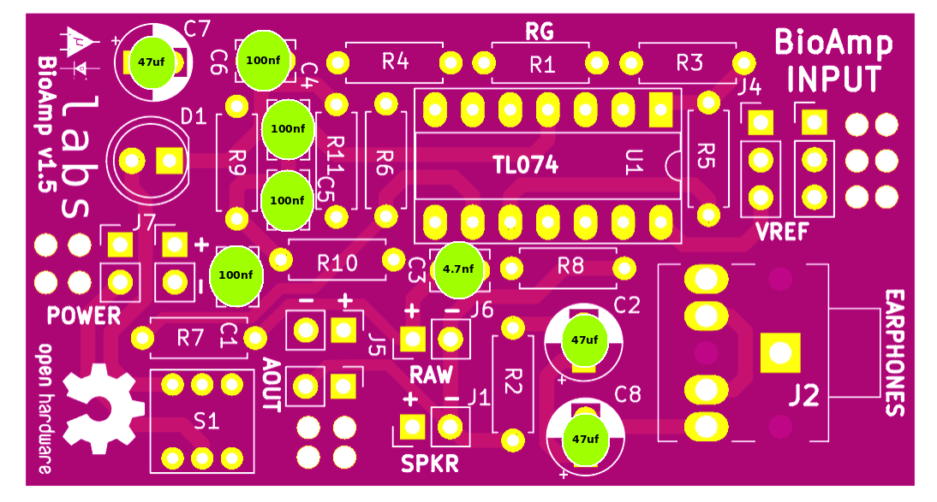

IC & LED
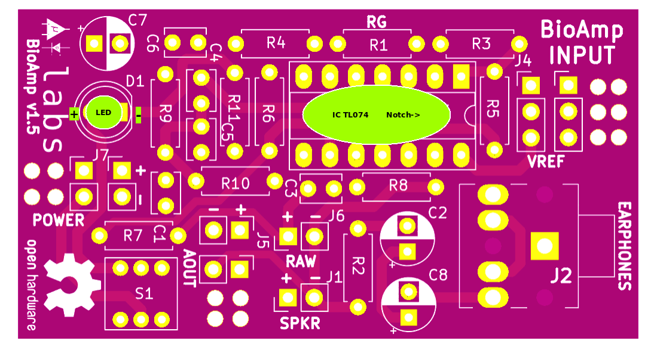

Connector & Switch
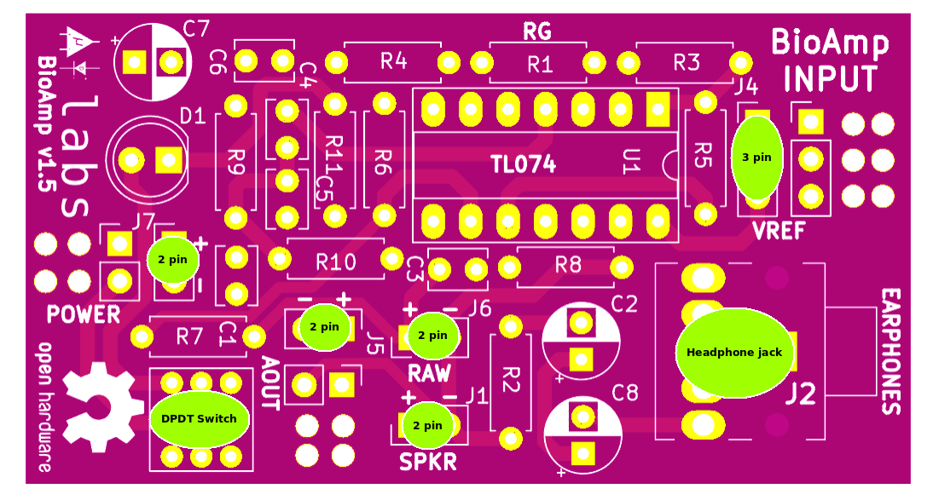

Cables
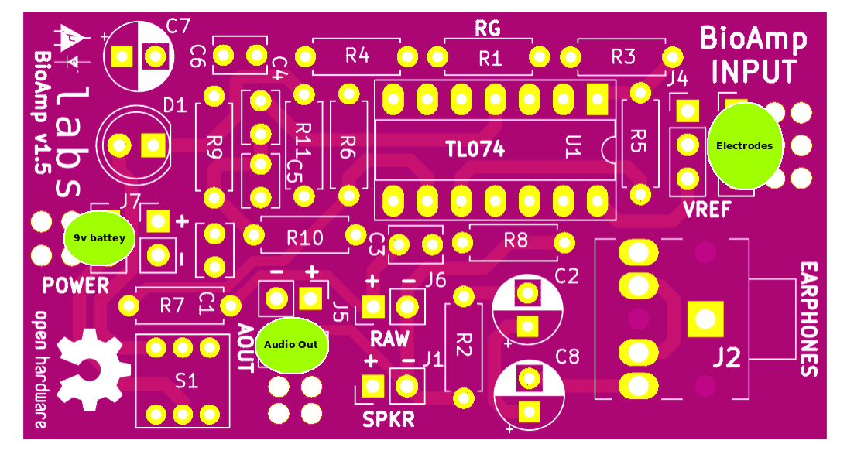

Fully Assembled BioAmp v1.5
